(Screen 1) (Screen 2)

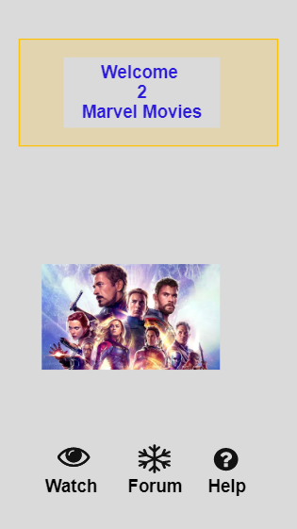 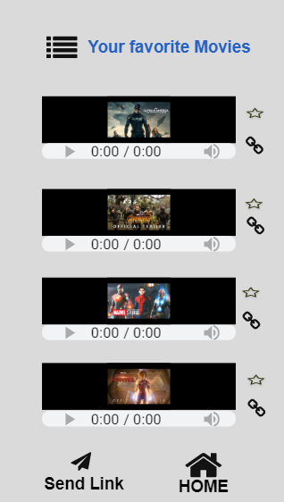

Movie rating screen

Click to copy the link of this movie. Popup will be displayed

Go to help menu

(Screen 3) (Screen 4)

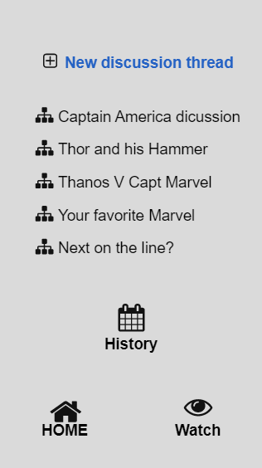 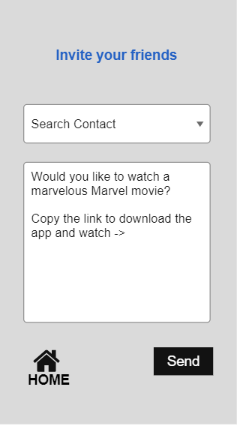

New discussion thread

History of past discussion

Select contact from phonebook

Sends message to the contact

**Definitions:**

**HOME:** Screen 1. Home screen or the main screen.

**Watch:** Screen 2. This is the screen to watch your favorite Marvel movies. List button will display list of movie in the collections.

**Forum:** Screen 3. This is the discussion thread. You can chat about various topics.

**Send Link:** Screen 4. This is the screen to send the link to your friends.